Themes of lectures:
- Theoretical and methodological analysis of the notion “national interest”
- The essence of National interests
- The national interests: problems as an analytical tool
- Critical Perspectives: Marxist and Anarchist Approaches
- Anarchism and ‘national interests’
- Progressive Perspectives: Liberal Approaches
- Challenging liberalism
- ‘Free trade’ and the national interest
- English school and national interests
- Defining the Enemy and National Defence
- Elements of national interest
- National Interests in sphere of Information
- National interests in the modern world
- National interests of CIS countries
- National interests of Kazakhstan
Summaries of lectures
- Theoretical and methodological analysis of the notion “national interest”
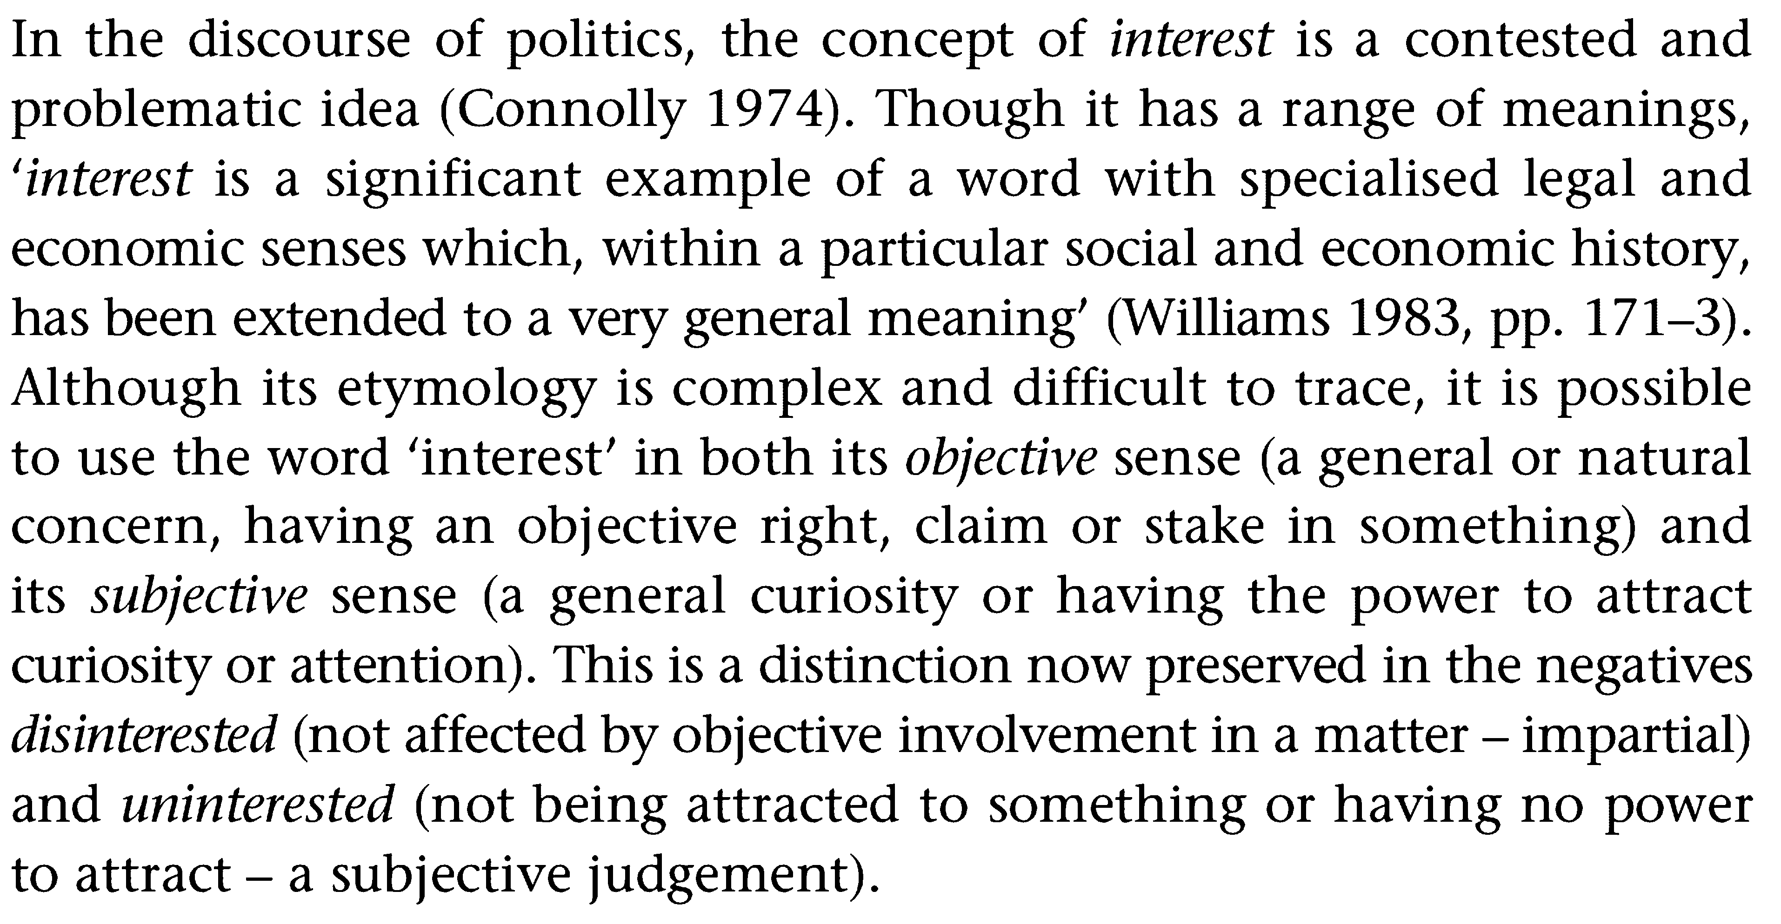
- The essence of National interests
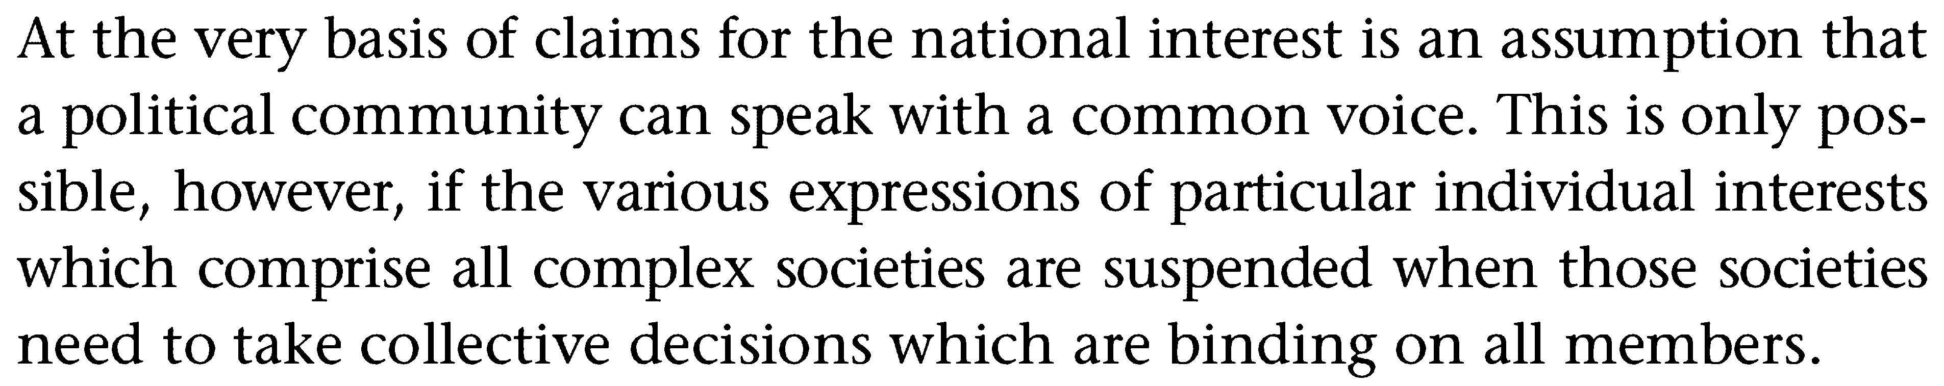
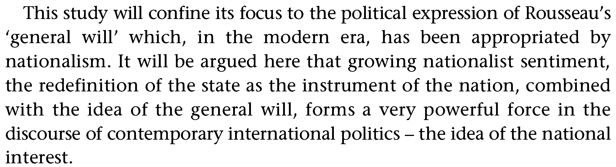

- The national interests: problems as an analytical tool
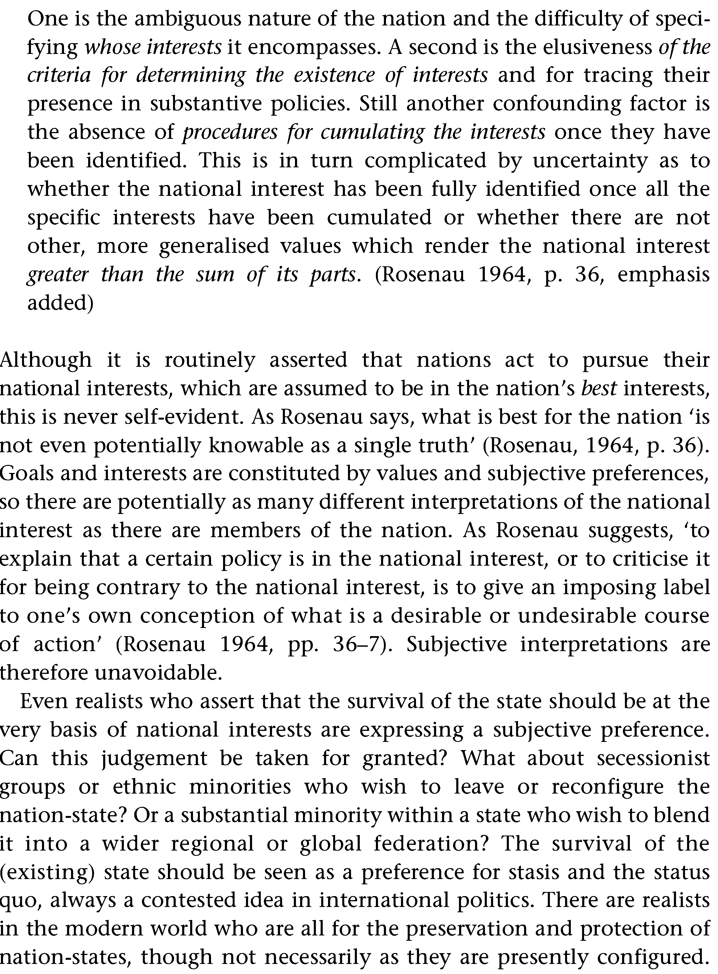

- Critical Perspectives: Marxist and Anarchist Approaches
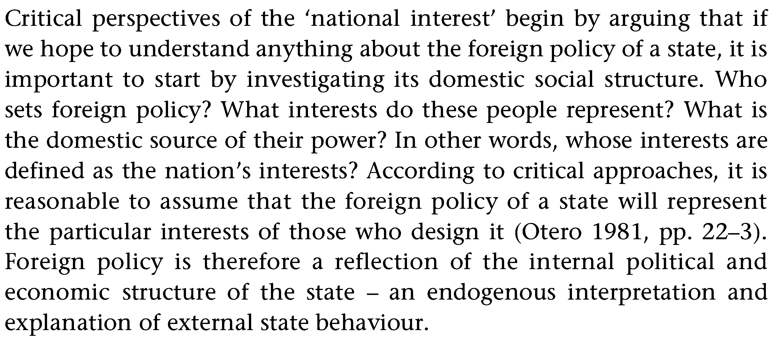
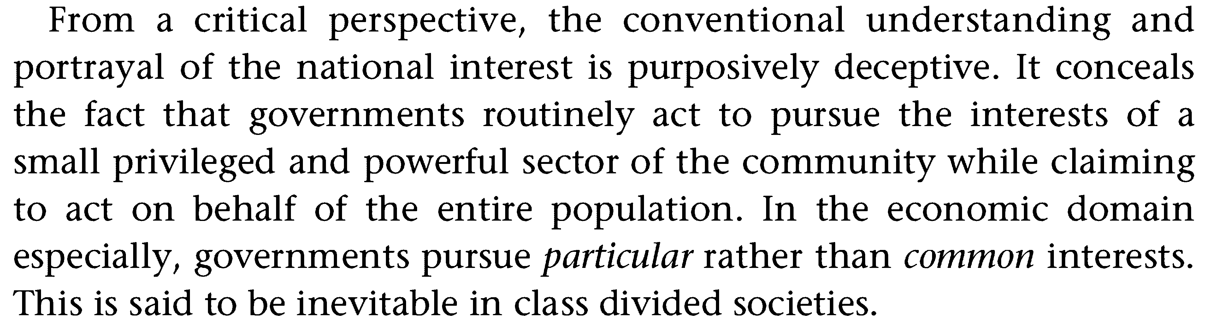
- Anarchism and ‘national interests’
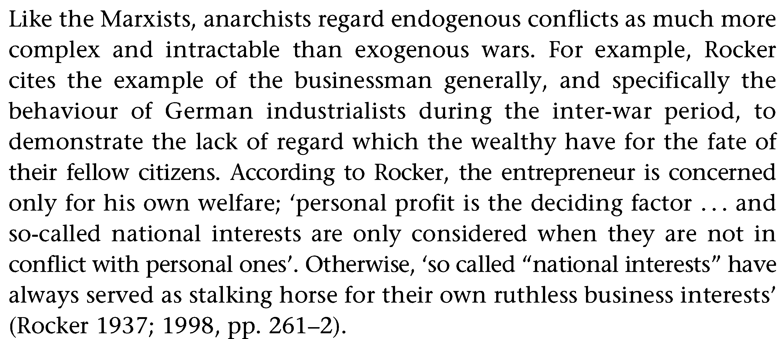
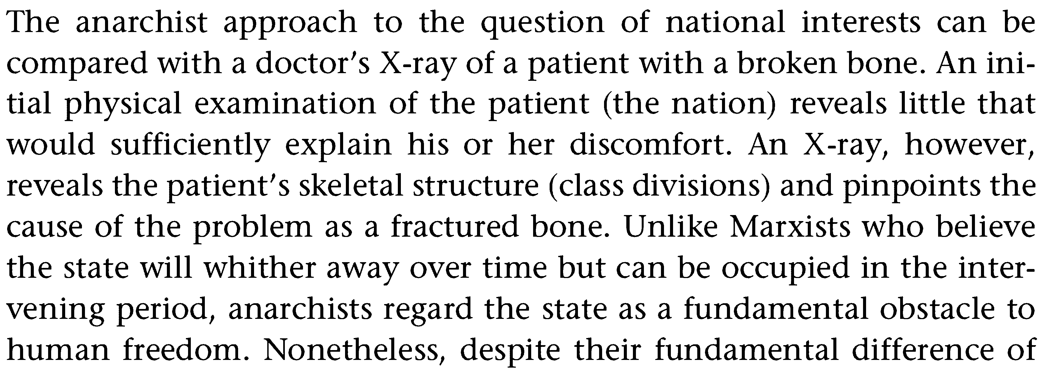

- Progressive Perspectives: Liberal Approaches
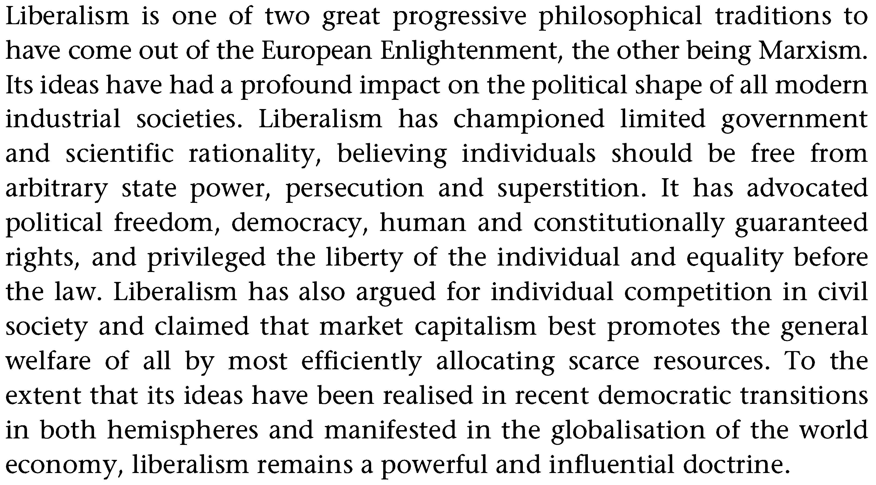
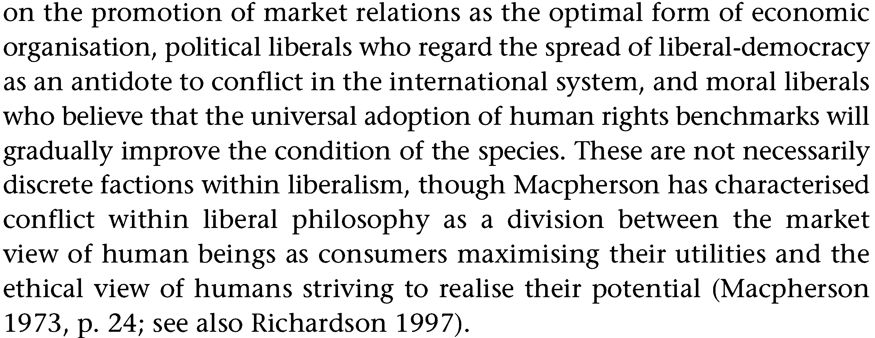
- Challenging liberalism
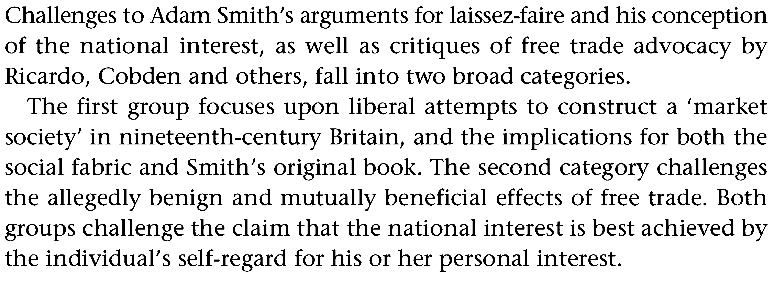

- ‘Free trade’ and the national interest
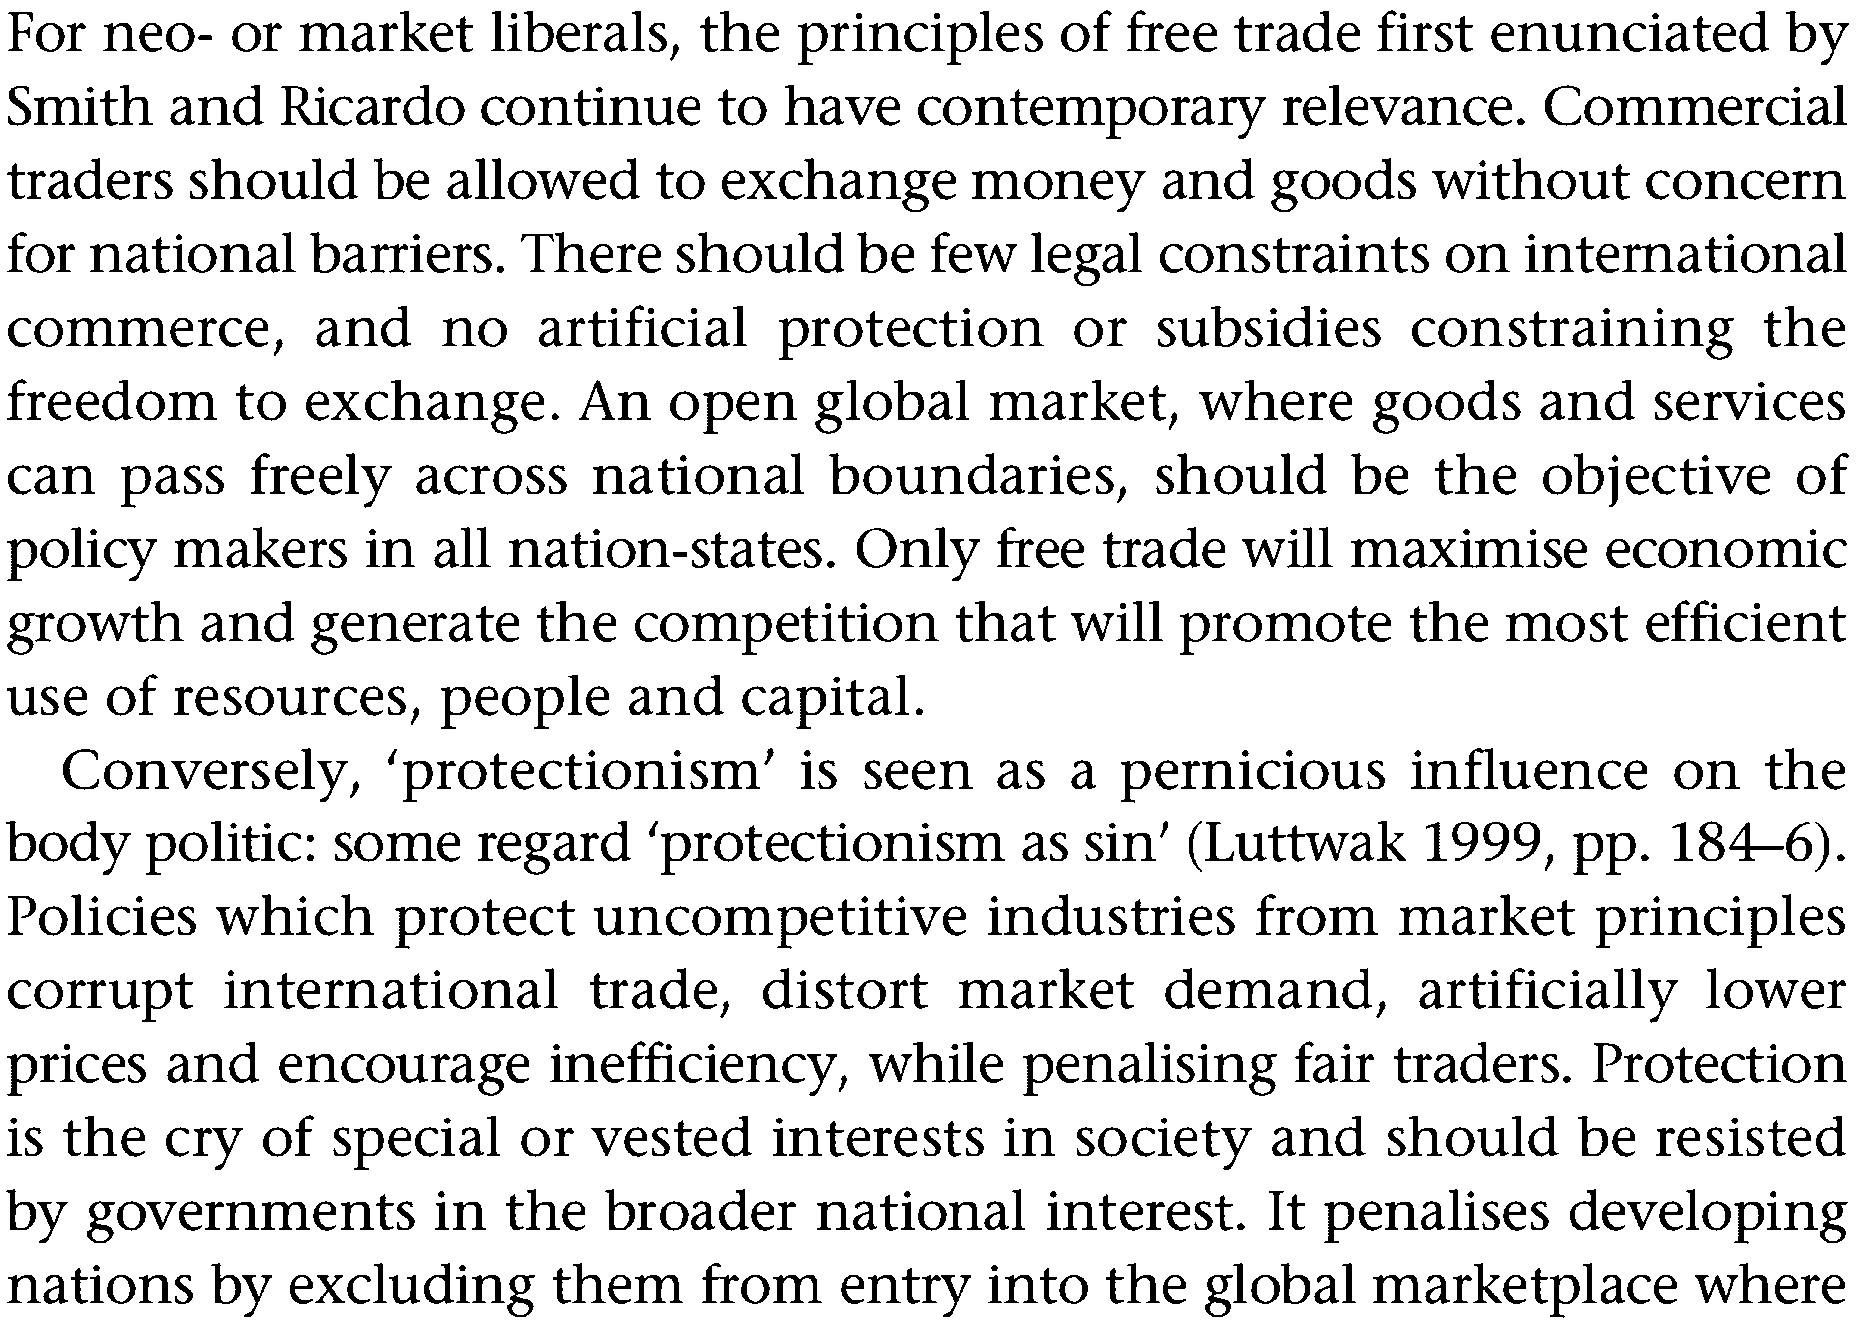
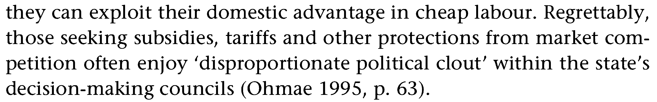
- English school and national interests
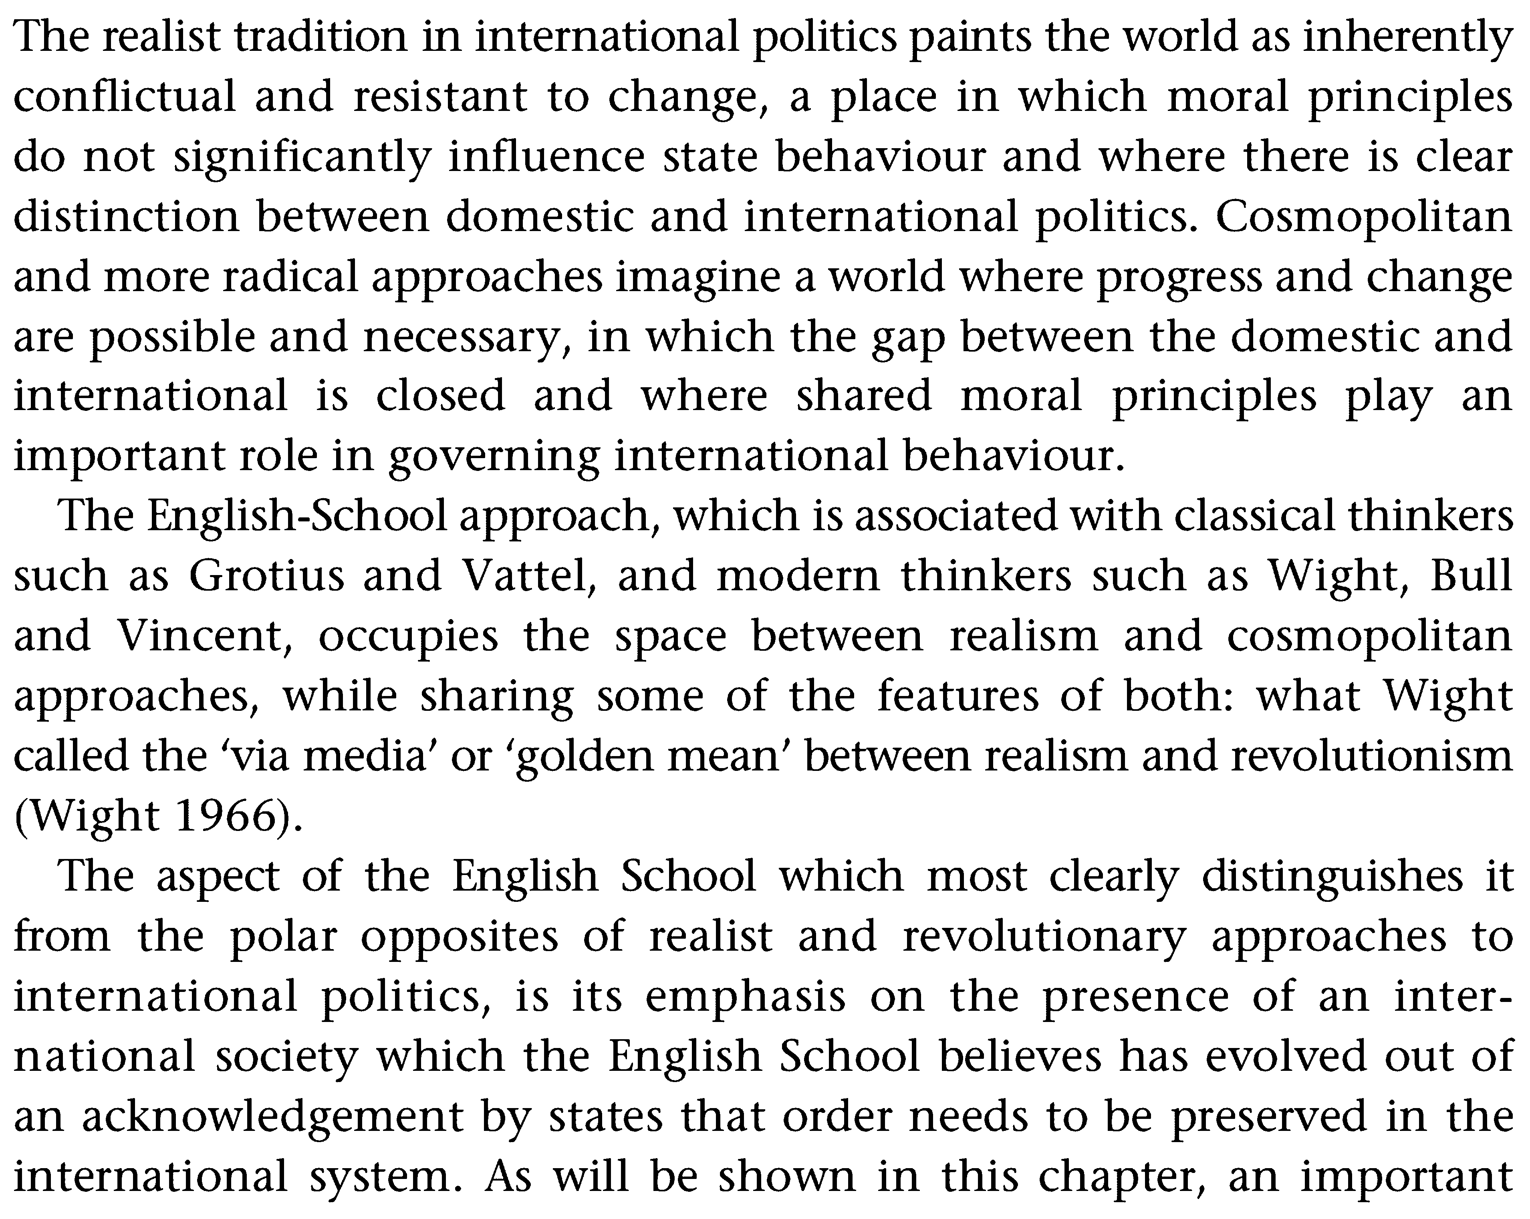

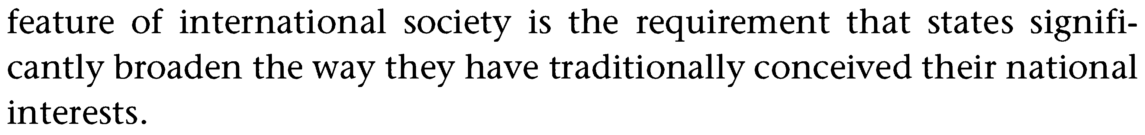
- Defining the Enemy and National Defence
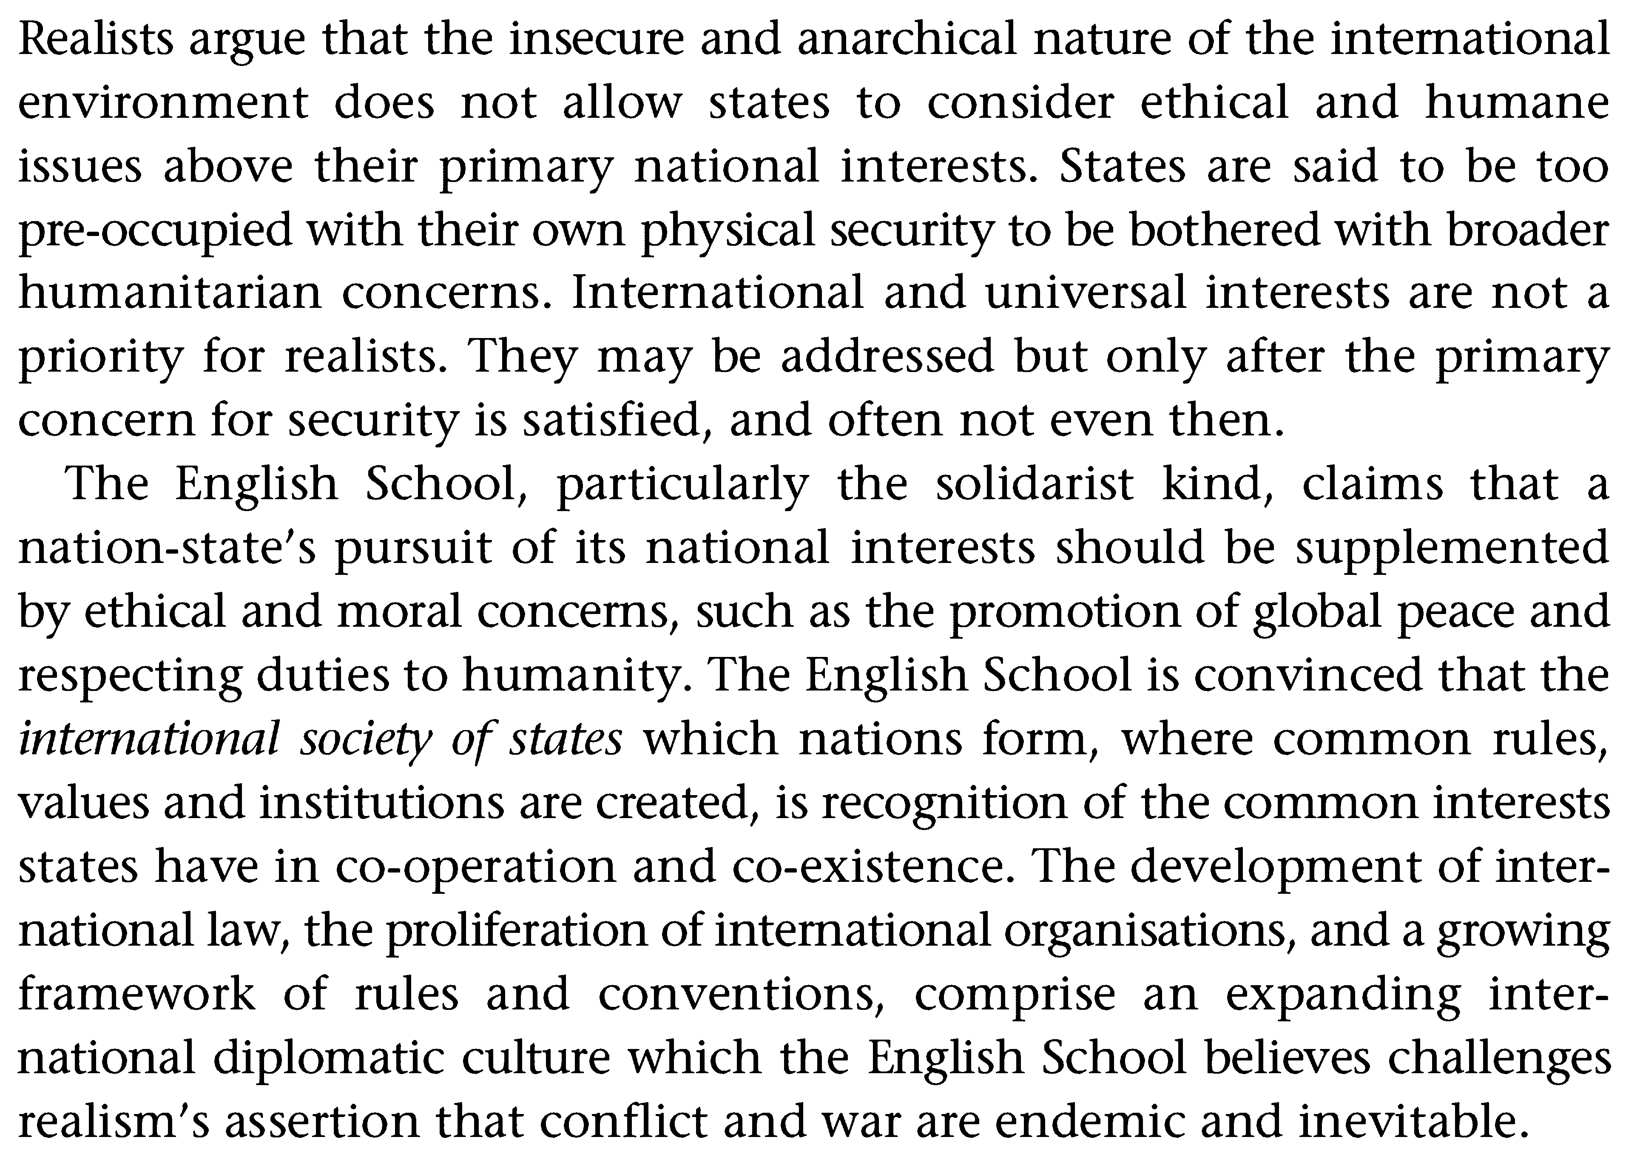
- Elements of national interest
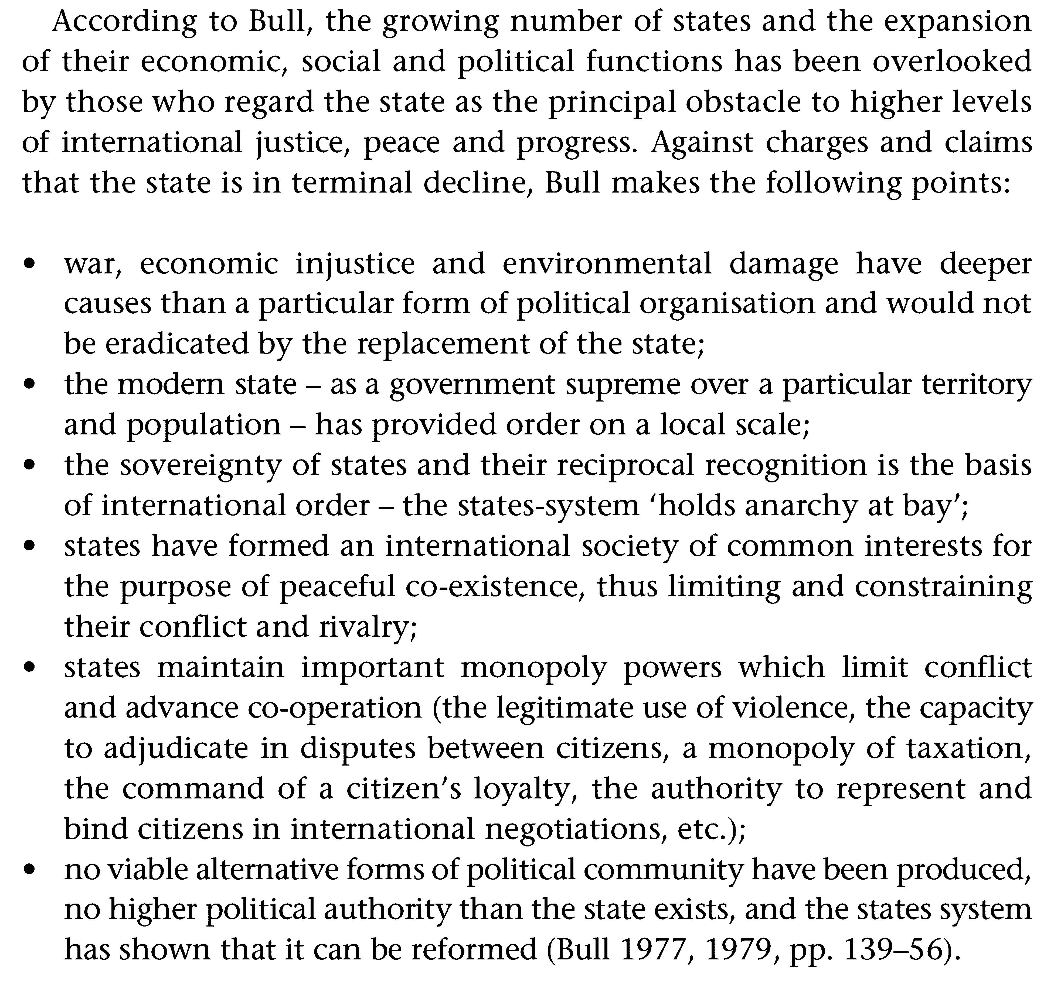
- National Interests in sphere of Information
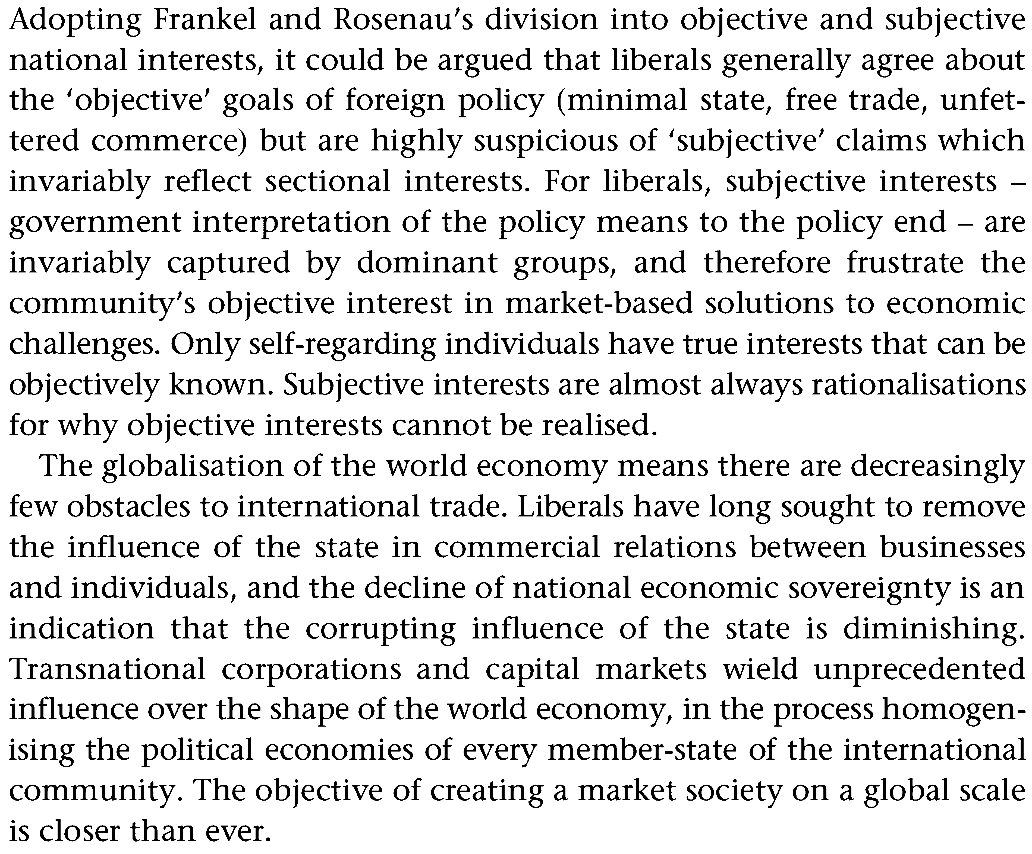
- National interests in the modern world
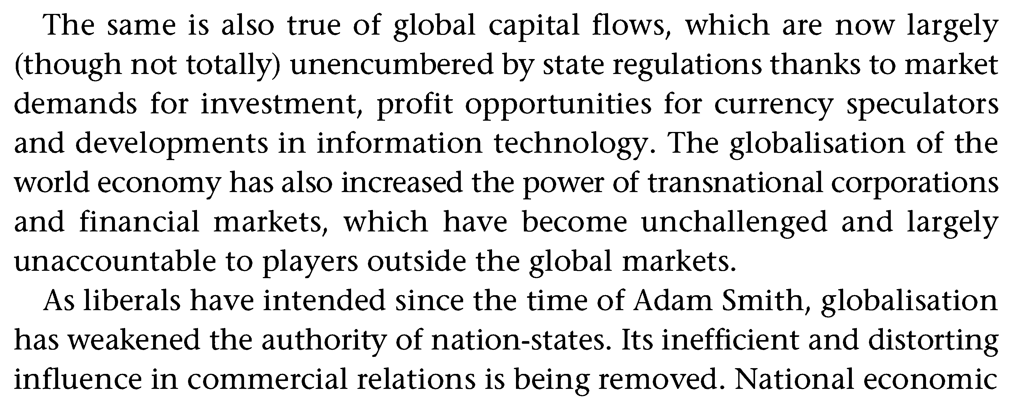

- National interests of CIS countries
Russia - one of the largest countries in the world, which has a rich historical and cultural traditions. Its economic, scientific-technical and military capabilities, a unique geographical position on the Eurasian continent allow Russia to play an important role in the modern world. Objectively remains common interests of Russia and other states on many security issues, including the proliferation of weapons, fighting terrorism and drug trafficking, environmental issues and nuclear safety. However, several states, efforts to weaken Russia in general and its impact on international politics. The basic concepts of the national security of Russia stated in the National Security Concept of the Russian Federation, approved by Presidential Decree of January 10, 2000 № 24. Under Russia's national security means the security of its multinational people as the bearer of sovereignty and the only source of power in the Russian Federation. Russia's national interests - a set of balanced interests of the individual, society and the state in the economic, political, social, international, informational, military, external, environmental and other services (Table 6). These interests are long-term and define the strategic objectives and the current problems of internal and foreign policy of the Russian Federation.

- National interests of Kazakhstan
Kazakhstan recently began lengthy and thorough legal proceedings into the tragic violence in Zhanaozen in the oil-rich western part of the country that left seventeen people dead and many others injured. The trials, which will last for months and scrutinize every aspect of the riots, will prove to the world that Kazakhstan respects the rule of law, believes in an open and transparent system of government, and does not tolerate violence against its citizens.
Many critics are loudly saying otherwise. But the formal trials, which began last week, are the beginning of what will prove to be a very long and deliberate process.
As Kazakhstan has demonstrated from the beginning of this terrible set of disturbances, it will spend as long as is necessary to ensure that the facts are brought to light and that those responsible—either in government or outside of it—are punished for their wrongdoing.
Protesters as well as police officers and local officials have been indicted and face criminal charges.
Despite accusations to the contrary, these proceedings will be fully open and transparent to the public, the media and the international community. The media will have unbridled access to every piece of evidence, every question proffered, every answer given and every ruling. Nothing will be hidden; nothing will be kept under wraps.
There's nothing to be proud of when it comes to the mass disturbances in Zhanaozen, and there are many people to blame. The police, the protesters, and local government officials and businesspeople all share responsibility. Kazakhstan mourns the lives lost and deeply regrets what occurred. The events have taught us many important lessons.
But these trials give us great hope and opportunity. They will allow Kazakhstan and its citizens to show the world that its system of justice works.

